
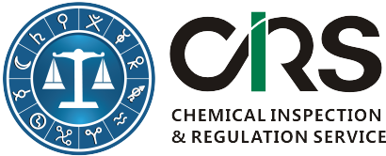
Service Order Form for China Food Safety National Standards

Please provide your company information (invoice address)
(*) starred items are mandatory to be filled in.
First Name(*):
Last Name(*):
Email (*):
Company or Organization(*):
Company Address(*):
Company VAT No. |  | Required for EU companies
Affiliated companies:
Please select appropriate service items you would like to order
Options | Content |  |  | USD | EUR
1 | English Version of GB 2762-2012 and valid part of GB 2762-2005  GB 2762-2012: Maximum Levels of Contaminants in Foods |  |  | 160 | 120
2 | English Version of GB 2761-2011  GB 2761-2011: Maximum Levels of Mycotoxins in foods |  |  | 100 | 75
3 | Receive all China food regulation updates and official suggestions for following one year. |  |  | Free | Free
Questions and Comments | E.g. We would like to pay in Euros.  E.g. We would like to order other National Standards in EN Version: GB xxxx - xxxx.
Please complete this form and send it to Alice.Yang@cirs-group.com. We will send above documents to you immediately after receiving this completed order form and send you an invoice after.  More China food regulation information could be found here. |  |  | CIRS Bank Information  Beneficiary Name: CIRS Ltd  Bank Name: Bank of Ireland  Bank Address: Wilton, Cork, Republic of Ireland  Sort Code: 902805  Account #: 90404884  BIC/Swift: BOFIIE2D  IBAN: IE15 BOFI 9028 0590 4048 84
Signature

Name:
Title:
Company:
Data:[DD/MM/YY]

