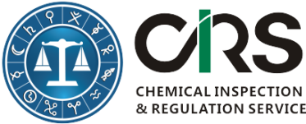
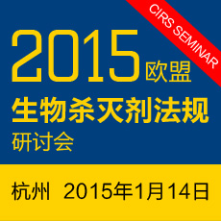


Registration Form - 2015 EU BPR Seminar
第一部分：公司和参会代表(Part I. Company and Delegates)
公司(Company)
地址(Address)
联系人(Contact Person)
邮箱（Email）
电话（Tel）
参会代表（Delegates） | 名  (First Name) | 姓  (Last Name) |  | 性别  (Gender) | Title（职务）
第二部分：报名流程（Part II. Registration procedures）
中国企业 (For Chinese Company only)  1. 请完成报名回执并随附公司开票信息(如需开具增值税专用发票，请提供税务登记证复印件)发送至会务组[Ethan.zheng@cirs-group.com.]。  2. 将会务费转账至如下账户。  3. 说明开票要求。增值税专用发票，增值税普通发票。 |  |  | For Oversea Company only（海外企业）  1. Please fill in this registration form and send back to Mr. Ethan Zheng at Ethan.zheng@cirs-group.com.  2. Please remit the registration fee to CIRS Ireland Bank and indicate ‘2015 BPR’.  3. Please provide invoice information if it is not consistent with the information in part I.
CIRS China Account  户名：杭州瑞旭产品技术有限公司  开户银行:工商银行杭州钱江支行  账号：1202021419900146022  SWIFT编码：ICBKCNBJZJP  行号（大宗支付号）：102331002149 |  |  | CIRS Bank Information  Beneficiary Name: CIRS Ltd  Bank Name: Bank of Ireland  Bank Address: Wilton, Cork, Republic of Ireland  Sort Code: 902805  Account #: 90404884  BIC/Swift: BOFIIE2D  IBAN: IE15 BOFI 9028 0590 4048 84
第三部分：问题和建议(Part III. Questions & Comments)
We are vegetarian.
Others__________________________________________.
会务组联系方式（Seminar Committee）
郑亦辰(Ethan Zheng)
邮箱 (Email): Ethan.zheng@cirs-group.com
电话(Tel): +86 571-89716572
传真(Fax): +86 571 87206533
- The Registration fee is 1000 RMB (160USD, 125Euro) with lunch ticket included.
- Please send this form to [Ethan.zheng@cirs-group.com] after it is completed; or contact +86 571 87206574 for assistance;
- After receiving this form, we will confirm your registration.

