
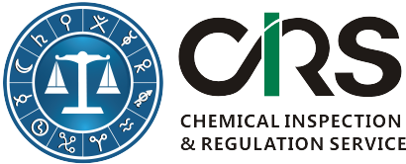
Service Order Form for Food Safety Law
“Food Safety Law of the People’s Republic of China” was passed by the Chinese Executive Committee 14th Meeting on 24 April 2015 and it will come into force on 1 October 2015.The Law includes 10 chapters with 154 articles. It was the basic law for all other food national standards and regulations.

Please provide your company information (invoice address)
(*) starred items are mandatory to be filled in.
First Name(*):
Last Name(*):
Email (*):
Company or Organization(*):
Company Address(*):
Company VAT No. |  | Required for EU companies
Affiliated companies:
Please select appropriate service items you would like to order
Options | Content |  |  | USD
1 | English Version of 2015 Food Safety Law of the People’s Republic of China |  |  | 500
2 | Receive all China food regulation updates and official suggestions for following one year. |  |  | Free
Questions and Comments
Please complete this form and send it to cathy.yu@cirs-group.com. We will send an invoice to you immediately after receiving this completed order form and send you above documents after.  More China food regulation information could be found here. |  |  | CIRS Bank Information  Beneficiary Name: CIRS Ltd  Bank Name: Bank of Ireland  Bank Address: Wilton, Cork, Republic of Ireland  Sort Code: 902805  Account #: 90404884  BIC/Swift: BOFIIE2D  IBAN: IE15 BOFI 9028 0590 4048 84
Signature

Name:
Title:
Company:
Data:[DD/MM/YY]

