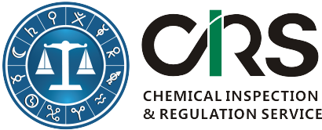
CHEMICAL INSPECTION & REGULATION SERVICE LTD.
SINGLETON HOUSE, LAURENCE STREET
DROGHEDA, CO. LOUTH, IRELAND
TEL: + 353 41 9806916 | FAX: +353 41 9806999
WEBSITE: http://www.cirs-reach.com

Workshop Registration Form

Attendee Information
First Name(*):
Last Name(*):
Email (*):
Company or Organization(*):
No. of Attendees and Their Names:
Telephone:
Pre-submitted Questions About K-REACH
* Mandatory Fields
- Please send this form to sj@cirs-group.com after it is completed; or contact +353 41 9806916 for assistance;
- After receiving this form, we will send you our bank information and confirm your registration;
- Cash is also accepted.

